**PRESENTED BY KING ADVISORY INC.**

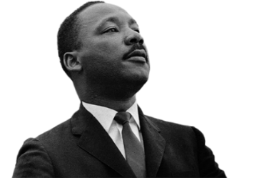**Saturday, August 10, 2019, 11:00AM-6PM**

**25th Annual Dr. Martin L. King, Jr.**

**Back-to-School Festival**

**“*Peace is the new MILLENNIUM, One Youth at a Time”***

**VOLUNTER REGISTRATION**

**Name:__________________________________ Address: __________________City/State/Zip___________**

**Phone:________________Cell:____________Work:______________ Email:_________________________**

**Social Media:______________Facebook___________Twitter___________Instatgram__________________**

**Age: _______ Have You Volunteered before:_____ If yes, how many years: _______**

**C:\Users\ecoggs\AppData\Local\Microsoft\Windows\Temporary Internet Files\Content.IE5\7PW67FZ4\MC900355235[1].wmfWhat Area(s):____________________________________________________________________**

***To volunteer at the Dr. Martin L. King, Jr. Center, 1531 W. Vliet Street, please check dates you are able to volunteer in the following areas:***

**___________Friday, August 9, 2019 3pm – 7pm (Set Up)**

**___________Saturday, August 10, 2019 8am – 12pm (Set Up)**

**___________Saturday, August 10, 2019 11am – 6pm (Festival Activities)**

**___________Saturday, August 10, 2019 4pm – 7pm (Clean Up)**

**Shirt size: S________ M________ L________XL________2XL_________3XL_________4XL_________**

***AGREEMENT***

**I understand that by signing this form, I have committed to volunteering at the 25th Annual Dr. Martin L. King, Jr. Back-to-School Festival on the day and/or days checked off above.**

**I agree to volunteer and participate in a brief volunteer orientation before the festival.**

**Signature:_____________________________________________________________Date:_______________**

**Please complete & return to the Dr. Martin L. King, Jr Center, 1531 W. Vliet Street, Milwaukee, WI 532 For more information please call LaDette Austin @ 414.979.1119 or email mlkb2sch@gmail.com**